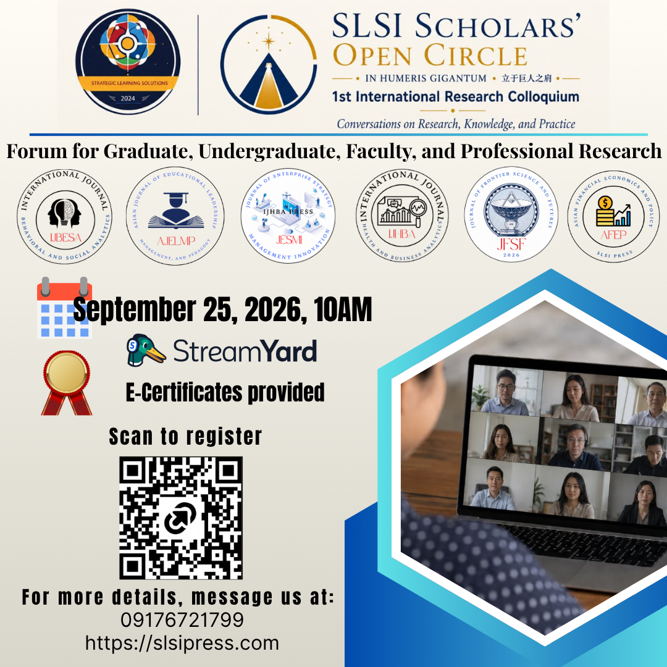
OFFICIAL PROGRAMME
SLSI Scholars’ Open Circle
1st International Research Colloquium
Conversations on Research, Knowledge, and Practice

Conference Information
Event | SLSI Scholars’ Open Circle – 1st International Research Colloquium
Theme | Conversations on Research, Knowledge, and Practice
Date and Time | 25 September 2026 | 10:00 AM onward
Platform | Online via StreamYard
This programme records the research presentations scheduled and presented during the colloquium, based on records maintained by the conference organizers.
Participating / Associated Journals
• Journal of Enterprise Strategy and Management Innovation
• International Journal of Behavioral and Social Analytics
• International Journal of Health and Business Analytics
• Asian Journal of Educational Leadership, Management and Pedagogy
• Frontier Science and Futures
• Asian Financial Economics and Policy
Official Research Presentation Schedule
Time | Presenter | Paper Title | Mode | Status
10:00–10:15 AM | Shuangxin Chen, PhD | Capital Depth and Entrepreneurial Vitality: Market Capitalization Growth and Cross-Border Investment Flows in the Philippines and ASEAN | Pre-recorded | Presented
10:15–10:30 AM | Randolph Sacdalan, PhD | Managerial Competencies and Organizational Citizenship Behavior among University Officials of Higher Educational Institutions: The Mediating Role of Employee Engagement toward a Developed Organizational Performance Framework | Pre-recorded | Presented
10:30–10:45 AM | Gay Marie Teodosio, BS | Education, Income, and the Dynamics of Formal Business Entry in the Philippines: An ARDL Analysis | Pre-recorded | Presented
10:45–11:00 AM | Andrea Gwyneth Atento, MBA Candidate | Influencer Parasocial Trust and Purchase Intention Among Young Adult Social Media Users | Live | Presented
11:00–11:15 AM | Gregorio S. Naldo, Jr., PhD | Love, Sexual Intimacy, and Relationship Satisfaction Among Persons Living with Human Immunodeficiency Virus | Live | Presented
11:15–11:30 AM | William Dela Cruz, PhD | Chicken, Egg, or Both? Disentangling Disposition and Distrust in Filipino Attitudes Toward Government Dole-Outs | Pre-recorded | Presented
11:30–11:45 AM | Hayalee Joy C. Vicente-Estoya, PhD | Mapping Attachment Styles, Hope, and Resilience Among Intimate Partner Violence Survivors: A Basis for Recovery-Oriented Interventions | Live | Presented
11:45 AM–12:00 PM | Elisa Tabujara, BS | Closing the Corridor: Women’s Advancement into Business Leadership Across the Philippines, Thailand, and Vietnam (2007–2023) | Live | Presented
12:00–12:15 PM | Qianwei Tan, PhD | Global Shocks, Local Ventures: Oil Prices, Dollar Strength, and China’s Economic Shifts as Determinants of Entrepreneurial Activity in the Philippines, 2006–2022 | Live | Presented
12:15–12:30 PM | Tong Feng, PhD | Do Remittances Save or Spend? Testing the Consumption-Investment Allocation Hypothesis for the Philippines Using WDI Time-Series Evidence, 2000–2023 | Live | Presented
12:30–12:45 PM | Cherry Ann Marie H. Espelita, DBA Candidate | From Credentials to Capabilities: Marketing Strategy and Value-Proposition Redesign in the Skills-Based MOOC Economy | Live | Presented
12:45–1:00 PM | Leah Quinto, PhD | Breast Cancer Burden in Transition: A GBD 2023 Forecasting Analysis of Global Trajectories and Health System Implications for Southeast Asia, East Asia, and Oceania, 2024–2050 | Live | Presented
1:00–1:15 PM | Charmaine Castaneda, MS | Presence, Cognitive Load, and Learning in Extended Reality: A Thematic Analytical Review | Live | Presented
1:15–1:30 PM | Ramon George O. Atento, PhD | Digital Reach, Consumption, and Equity Market Deepening: Evidence from ASEAN-5 | Live | Presented
1:30–1:45 PM | Liu Bo, PhD | Organizational Climate and Faculty Job Satisfaction in Selected Chinese Higher Education Institutions | Live | Presented
Detailed Presentation Record
1. Shuangxin Chen, PhD
Institution: Zhengzhou Shengda University of Economics, Business & Management
Country: China
Paper Title: Capital Depth and Entrepreneurial Vitality: Market Capitalization Growth and Cross-Border Investment Flows in the Philippines and ASEAN
Co-author(s): Ramon George O. Atento, PhD; Rey Fernan Refozar, PhD; Lalaine Manalo, PhD; Qianwei Tan, PhD; Tong Feng, PhD
Research Area: Applied Economics; Entrepreneurship; International Investment and Capital Markets
Journal: Journal of Enterprise Strategy and Management Innovation
Presentation: Pre-recorded | 10:00–10:15 AM | Presented
2. Randolph Sacdalan, PhD
Institution: Lyceum of the Philippines University – Batangas
Country: Philippines
Paper Title: Managerial Competencies and Organizational Citizenship Behavior among University Officials of Higher Educational Institutions: The Mediating Role of Employee Engagement toward a Developed Organizational Performance Framework
Co-author(s): None
Research Area: Organizational Behavior; Leadership and Management; Employee Engagement
Journal: Journal of Enterprise Strategy and Management Innovation
Presentation: Pre-recorded | 10:15–10:30 AM | Presented
3. Gay Marie Teodosio, BS
Institution: First Asia Institute of Technology and the Humanities
Country: Philippines
Paper Title: Education, Income, and the Dynamics of Formal Business Entry in the Philippines: An ARDL Analysis
Co-author(s): Andrea Gwyneth Atento, MBA Candidate; Rhinella G. Mesias; Camille Roxas; Ramon George O. Atento, PhD
Research Area: Entrepreneurship; Applied Economics; Business Formation and Development
Journal: Journal of Enterprise Strategy and Management Innovation
Presentation: Pre-recorded | 10:30–10:45 AM | Presented
4. Andrea Gwyneth Atento, MBA Candidate
Institution: Polytechnic University of the Philippines Open University
Country: Philippines
Paper Title: Influencer Parasocial Trust and Purchase Intention Among Young Adult Social Media Users
Co-author(s): Ramon George O. Atento, PhD
Research Area: Consumer Behavior; Social Media Marketing; Parasocial Interaction
Journal: International Journal of Behavioral and Social Analytics
Presentation: Live | 10:45–11:00 AM | Presented
5. Gregorio S. Naldo, Jr., PhD
Institution: Lyceum of the Philippines University – Batangas
Country: Philippines
Paper Title: Love, Sexual Intimacy, and Relationship Satisfaction Among Persons Living with Human Immunodeficiency Virus
Co-author(s): None
Research Area: Health Psychology; Relationship and Sexual Health; Psychosocial Well-Being
Journal: International Journal of Behavioral and Social Analytics
Presentation: Live | 11:00–11:15 AM | Presented
6. William Dela Cruz, PhD
Institution: Austin Independent School District
Country: United States
Paper Title: Chicken, Egg, or Both? Disentangling Disposition and Distrust in Filipino Attitudes Toward Government Dole-Outs
Co-author(s): Ramon George O. Atento, PhD
Research Area: Social and Political Psychology; Institutional Trust; Public Policy Attitudes
Journal: International Journal of Behavioral and Social Analytics
Presentation: Pre-recorded | 11:15–11:30 AM | Presented
7. Hayalee Joy C. Vicente-Estoya, PhD
Institution: Lyceum of the Philippines University – Batangas
Country: Philippines
Paper Title: Mapping Attachment Styles, Hope, and Resilience Among Intimate Partner Violence Survivors: A Basis for Recovery-Oriented Interventions
Co-author(s): None
Research Area: Trauma and Clinical Psychology; Resilience; Intimate Partner Violence Recovery
Journal: International Journal of Behavioral and Social Analytics
Presentation: Live | 11:30–11:45 AM | Presented
8. Elisa Tabujara, BS
Institution: Kidz Village International Kindergarten and Kidz Learning Centre
Country: Thailand
Paper Title: Closing the Corridor: Women’s Advancement into Business Leadership Across the Philippines, Thailand, and Vietnam (2007–2023)
Co-author(s): Leah Quinto, PhD; Ramon George O. Atento, PhD; Andrea Gwyneth Atento, MBA Candidate; Cherry Ann Marie H. Espelita, DBA Candidate
Research Area: Women and Leadership; Gender and Management; Comparative Business Studies
Journal: Journal of Enterprise Strategy and Management Innovation
Presentation: Live | 11:45 AM–12:00 PM | Presented
9. Qianwei Tan, PhD
Institution: Zhengzhou Shengda University of Economics, Business & Management
Country: China
Paper Title: Global Shocks, Local Ventures: Oil Prices, Dollar Strength, and China’s Economic Shifts as Determinants of Entrepreneurial Activity in the Philippines, 2006–2022
Co-author(s): Cherry Ann Marie H. Espelita, DBA Candidate; Andrea Gwyneth Atento, MBA Candidate; Ramon George O. Atento, PhD; Leah Quinto, PhD; Gay Marie Teodosio, BS; Tong Feng, PhD; Shuangxin Chen, PhD
Research Area: Entrepreneurship; Applied Macroeconomics; Predictive Analytics
Journal: Journal of Enterprise Strategy and Management Innovation
Presentation: Live | 12:00–12:15 PM | Presented
10. Tong Feng, PhD
Institution: Qilu University of Technology (Shandong Academy of Sciences)
Country: China
Paper Title: Do Remittances Save or Spend? Testing the Consumption-Investment Allocation Hypothesis for the Philippines Using WDI Time-Series Evidence, 2000–2023
Co-author(s): Ramon George O. Atento, PhD; Gilbert Tolentino
Research Area: Development Economics; Remittances and International Finance; Consumption and Investment Dynamics
Journal: Journal of Enterprise Strategy and Management Innovation
Presentation: Live | 12:15–12:30 PM | Presented
11. Cherry Ann Marie H. Espelita, DBA Candidate
Institution: Silverline College
Country: Australia
Paper Title: From Credentials to Capabilities: Marketing Strategy and Value-Proposition Redesign in the Skills-Based MOOC Economy
Co-author(s): Ramon George O. Atento, PhD
Research Area: Marketing Strategy; Digital Education Markets; Skills-Based Economy
Journal: Journal of Enterprise Strategy and Management Innovation
Presentation: Live | 12:30–12:45 PM | Presented
12. Leah Quinto, PhD
Institution: De La Salle Medical and Health Sciences Institute
Country: Philippines
Paper Title: Breast Cancer Burden in Transition: A GBD 2023 Forecasting Analysis of Global Trajectories and Health System Implications for Southeast Asia, East Asia, and Oceania, 2024–2050
Co-author(s): Majie Liza Diwa, MD; Ramon George O. Atento, PhD
Research Area: Global Health; Epidemiology and Disease Burden; Health Forecasting
Journal: International Journal of Health and Business Analytics
Presentation: Live | 12:45–1:00 PM | Presented
13. Charmaine Castaneda, MS
Institution: Adamson University
Country: Philippines
Paper Title: Presence, Cognitive Load, and Learning in Extended Reality: A Thematic Analytical Review
Co-author(s): Ramon George O. Atento, PhD; Leah F. Quinto, PhD; Andrea Gwyneth Atento, MBA Candidate; Victor Jolo Maranan, MSc
Research Area: Educational Technology; Extended Reality; Cognitive Load and Learning Sciences
Journal: Frontier Science and Futures
Presentation: Live | 1:00–1:15 PM | Presented
14. Ramon George O. Atento, PhD
Institution: First Asia Institute of Technology and the Humanities; Lyceum of the Philippines University – Manila
Country: Philippines
Paper Title: Digital Reach, Consumption, and Equity Market Deepening: Evidence from ASEAN-5
Co-author(s): Liezl Marie Lantin
Research Area: Financial Economics; Capital Market Development; Digital Economy
Journal: Asian Financial Economics and Policy
Presentation: Live | 1:15–1:30 PM | Presented
15. Liu Bo, PhD
Institution: Northeast Petroleum University
Country: China
Paper Title: Organizational Climate and Faculty Job Satisfaction in Selected Chinese Higher Education Institutions
Co-author(s): Ramon George O. Atento, PhD
Research Area: Educational Leadership and Management; Organizational Climate; Faculty Job Satisfaction
Journal: Asian Journal of Educational Leadership, Management and Pedagogy
Presentation: Live | 1:30–1:45 PM | Presented

OFFICIAL PRESENTATION RECORD
Presentation status in this programme reflects the conference organizer’s official record. For institutional verification, reference the presenter’s name, paper title, and scheduled presentation time.

